**NC Math 3 Honors Course Syllabus**

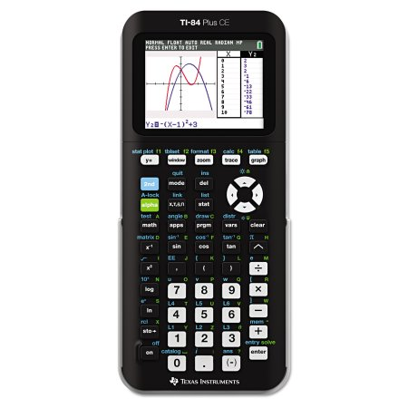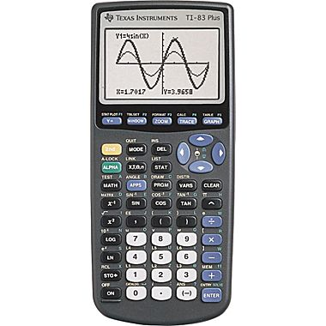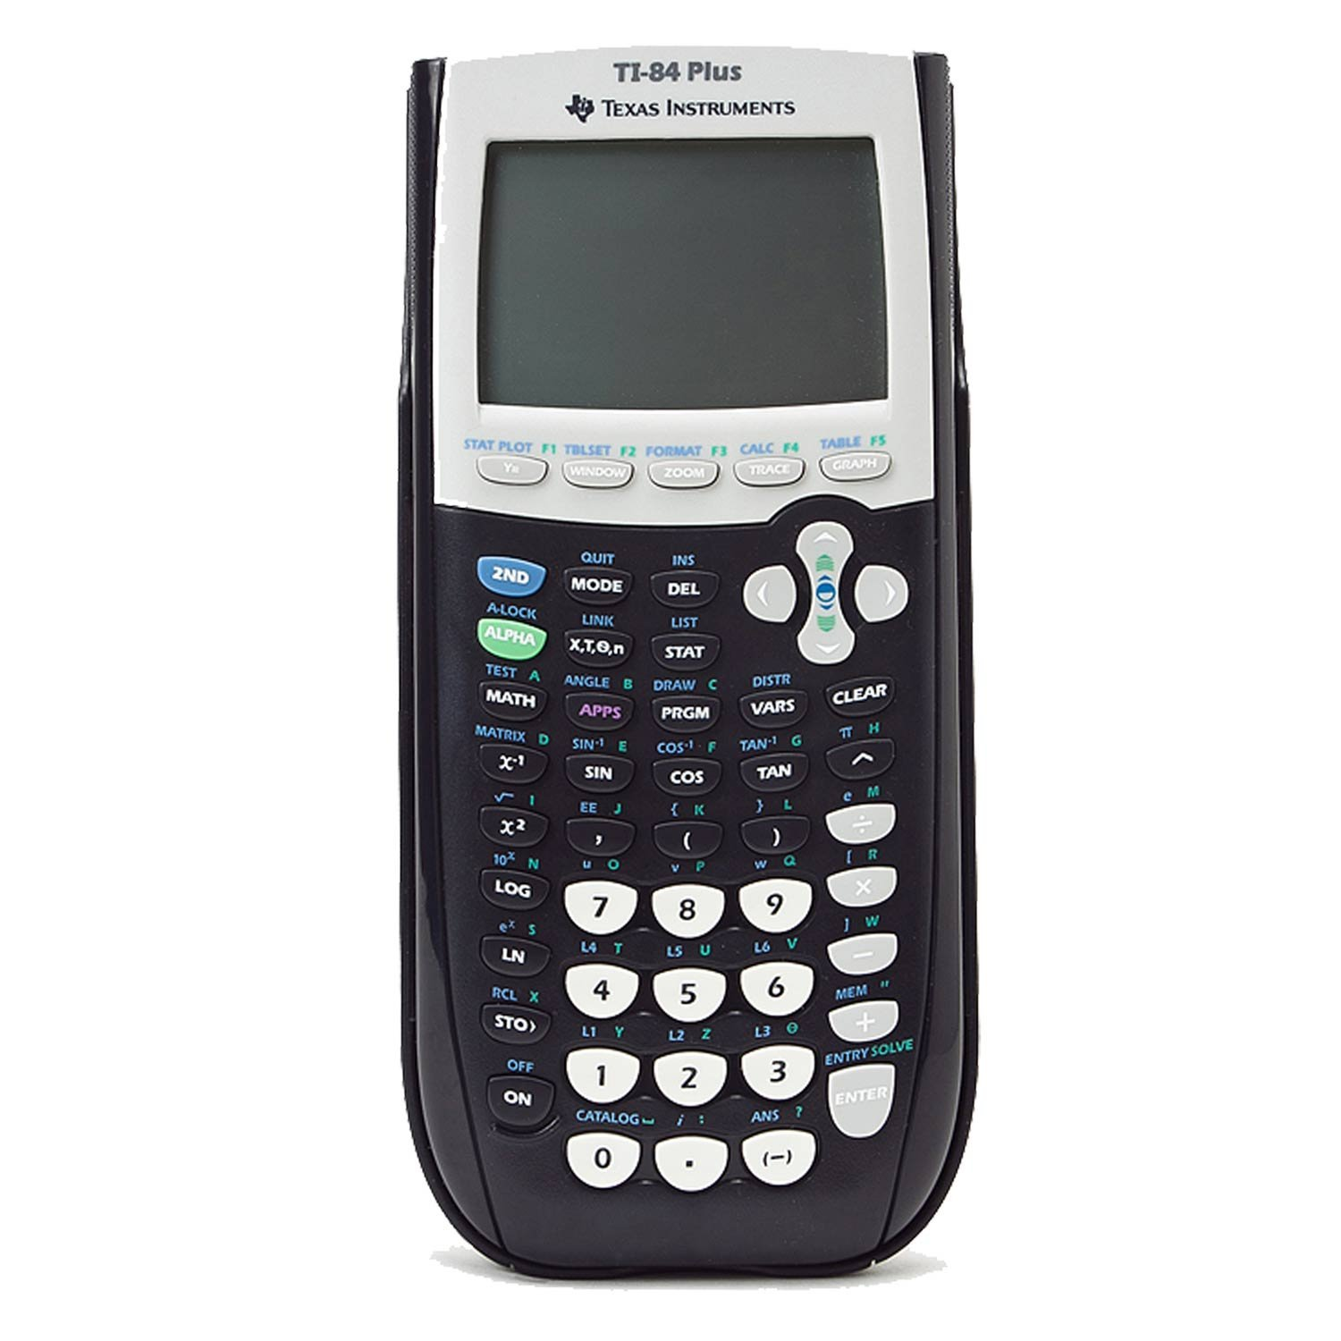**Fall 2017**

Teacher Contacts

Sherin Hassane [shassane@wcpss.net](mailto:shassane@wcpss.net)

Eunice Haynes [ehaynes@wcpss.net](mailto:ehaynes@wcpss.net)

Emily Merkel [emerkel@wcpss.net](mailto:emerkel@wcpss.net)

Courtney Shagena [ccshagena@wcpss.net](mailto:ccshagena@wcpss.net)

Emily Berkeley [eberkeley@wcpss.net](mailto:eberkeley@wcpss.net)

Recommended materials

* Three-ring Binder + Loose Leaf Paper or 3-Subject Notebook
* Writing Utensils
* TI-83 Series or equivalent Graphing Calculator**\***

**\***A calculator is an excellent investment in your education and will be an integral part of class and homework assignments and assessments. The TI-83+, TI-84+ or TI-Inspire will meet the calculator requirements for all math and science courses offered at PCHS as well as EOC, NCFE, and SAT testing and many college courses.

Unit Topics Covered

1. Statistics: At the end of this unit, students will understand statistics as a process of making inferences about a population (parameter) based on results from a random sample (statistic).
2. Functions & Their Inverses: This unit builds upon students’ previous work with modeling functions in Math 1 and Math 2. It develops the notion of the inverse function of quadratic, exponential, and linear functions and introduces piecewise-defined and absolute value functions through multiple representations, i.e. graphing, equations, tables, verbal descriptions, etc.
3. Logarithmic Functions: Following the functions unit, this unit continues to build upon familiarity with exponents and exponential functions and introduces logarithmic functions. Additionally, solving exponential and logarithmic equations involves using algebraic operations students have practiced in Math 1 and Math 2.
4. Reasoning with Geometry: This unit transitions into geometric concepts with an emphasis on reasoning, justification, and formalizing proof. Students will prove more theorems about triangles and parallelograms that they are familiar with from Math 1 and Math 2.
5. Polynomial Functions: Students will begin by continuing their modeling work with expressions or functions that represent familiar topics such as perimeter and area, and volume. The modeling of volume will introduce a cubic polynomial and present the opportunity to begin exploring polynomials of higher degree more in depth.
6. Rational Functions: This unit is intended to develop students’ understanding of rational functions so they can work with complex fractions correctly.
7. Trigonometric Functions: Understand and interpret the key features, uses and limitations of multiple representations of trigonometric functions that model real world periodic behavior.
8. Modeling with Geometry: This unit transitions from polynomial work to geometric concepts that require the use of algebra, culminating in a collaborative project.

Office Hours/Extra Help

Extra help in mathematics courses will be available during the SMART lunch sessions, these SMART lunch sessions will be held on *Monday (B half) and Thursday (A half)*.

Absences

If you are absent, it is *your responsibility to catch up* on missed assignments. Missed quizzes and tests will be made up on the day you return. Exceptions will be made on a case-by-case basis when discussed with your teacher *prior* to the absence.

Remediation

Students are strongly encouraged to correct *every* test and quiz for student engagement points. Also, because each unit test will include questions from the previous unit, students have the opportunity to replace a grade by doing better on the next test. The original test grade will be averaged with the better grade and replaced. This means students should constantly be reviewing material and be sure to *correct every test* in preparation for the next.

Final Grade Breakdown

40% 1st QUARTER

40% 2nd QUARTER

20% FINAL EXAM

Current Grades

Grades are *posted regularly online*. Parents and students can access these grades through PowerSchool. Information on how to access this information is available through the main office. If you have any questions regarding your child’s grades, please contact the teacher as soon as possible.

Quarter Grade Categories

**Major Assessments:** You can expect at least one test or cumulative project per unit. Tests will be part short answer and part multiple choice and will cover material from the current unit along with review from previous units. *Test corrections are always strongly encouraged* to earn student engagement points and improve for the final examination.

**Minor Assessments:** You can expect at least one quiz per unit. *Quiz corrections are always strongly encouraged* to earn student engagement points and improve for the unit test or cumulative project.

**Homework / Classwork:** You can expect homework assignments nightly that will be graded for effort. Homework is complete if all problems have been attempted and all work is shown. It is *your responsibility to ask for help* on the questions you are unable to solve on your own or with the help of a tutor/peer.

**Student Engagement:** Completing content-related activities and getting signatures from your teacher earn this grade. Please see the separate student engagement rubric for suggested activities. If you lose your rubric, you will lose all of your signatures as well so *keep it in a safe place* all semester long.

Quarter Grade Breakdown

60% Major Assessments

30% Minor Assessments

5% Homework / Classwork

5% Student Engagement



Canvas

We will be using Canvas for announcements, student communication, notes, HW assignments, and other miscellaneous assignments. Because of the importance of the site, *parents of students without regular internet access should inform the instructor as soon as possible.*